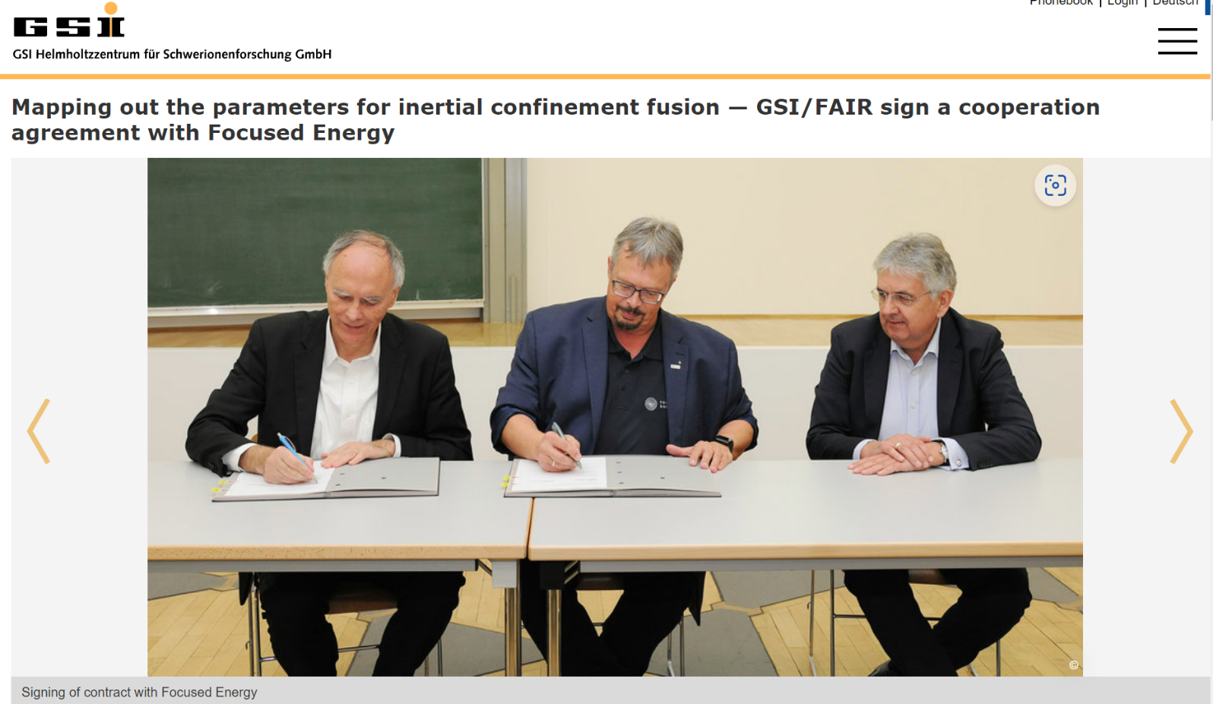
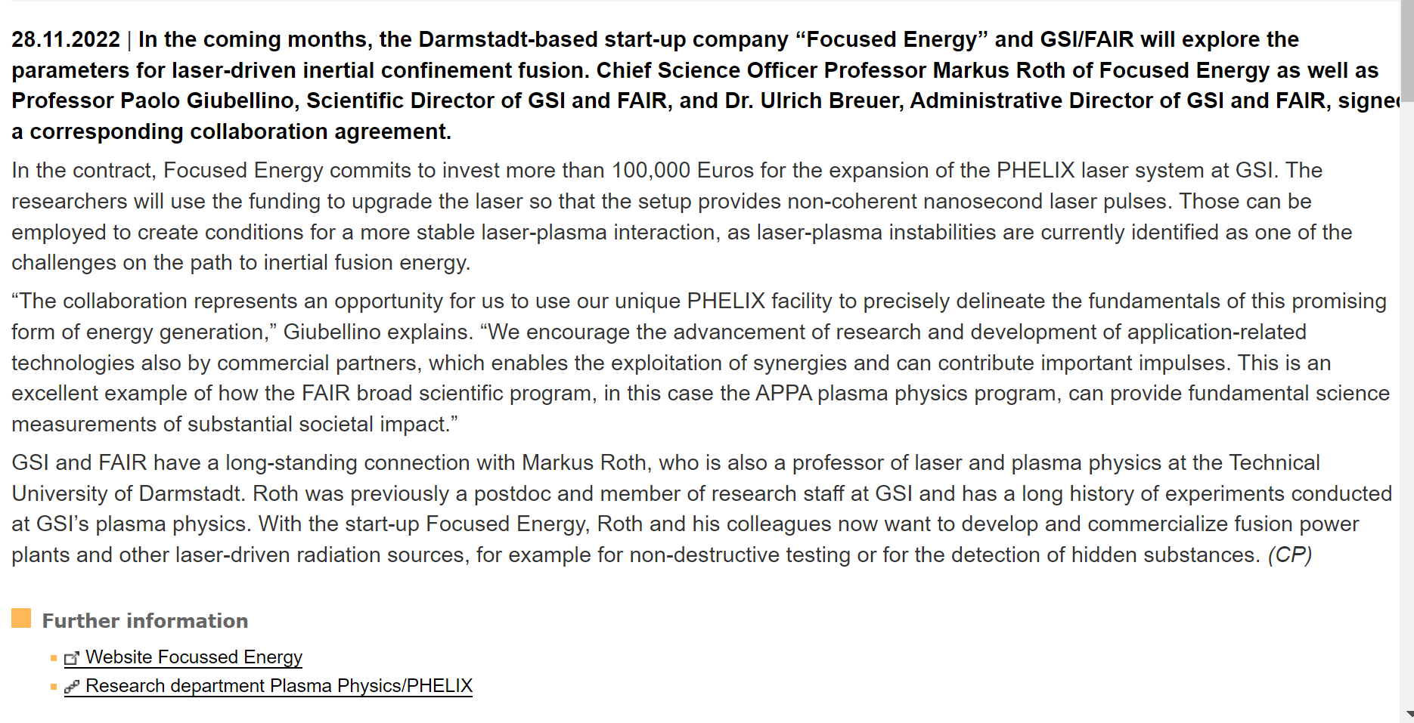
https://focused-energy.world/
https://www.gsi.de/en/work/research/appamml/plasma_physicsphelix

GSI - Details

